NMS 1
Boarding Principles and Practices

ISI | NMS1
NMS (if applicable) | NMS1
Policy Owner (SLT) | MGP
Governor Responsible | N/A
Gov Annual Review Date | N/A
Policy Last Updated | 16.06.22 | MGP
Policy Revision due | 16.06.23
On the Website | Yes

Please read in conjunction with:

- Gold Standard of Pastoral Care

OUR BOARDING PRINCIPLES AND PRACTICE

OUR PRINCIPLES ARE THAT IN OUR HOUSES WE:

- Settle, develop and grow.
- Embrace fun, friendships and challenges.
- Inspire each other to be ambitious about who we are and what we can achieve.

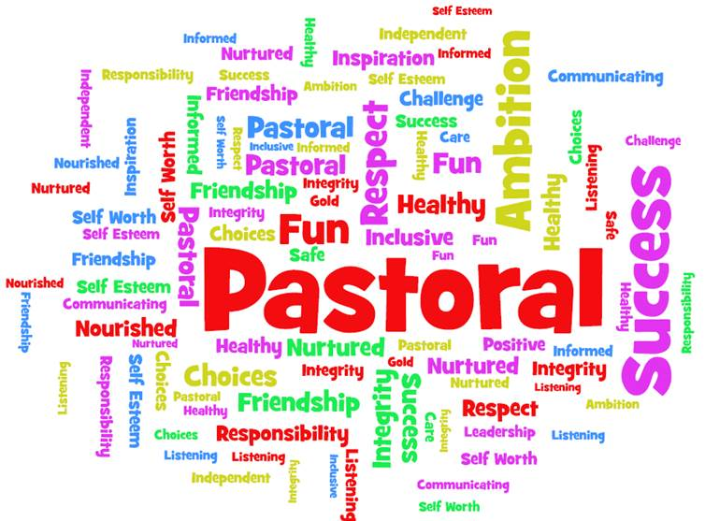

OUR BOARDING PRINCIPLES AND PRACTICE

OUR PRACTICES ARE:

Before a student arrives at the school.
- We seek full and detailed information of their background, identified learning needs, family situation and health. This information is distributed efficiently to those who need to know.
- Each student will attend a new student event to begin the familiarisation process.

Whilst at the school every student will receive:
- A full and proper induction particularly for any pupil joining the school at an unusual time
- Leadership and ‘parenting’ from the housemaster/mistress
- Guidance, support, encouragement and advocacy from their tutor
- Leadership opportunities within the House and School
- Accommodation in well maintained and cared for boarding house
- An understanding of the variety of people who they can talk to if they wish to seek help
- A PSHE course which is relevant to their age and experience
- Advice on keeping safe, with particular reference to cyber-safety
- The opportunity to have their voice heard in the house and school
- Healthy meals and snacks
- Advice and guidance on leading a healthy life style
- A warm and friendly environment in which to feel secure and happy
- Support in personal spiritual development
- Help to develop respect for others both locally and in a diverse world
- Help to develop respect for the property of others.
- Encouragement to have an inquiring mind, to read and to think
- Opportunities to take part in structured and safe social activities appropriate to their age
- Opportunities to explore careers and prepare for life after Bloxham
- Instruction as to how to improve their communication skills
- Support, guidance and help to form positive relationships
- Instruction to develop listening skills
- Nurturing to build and develop self-esteem and that of others
- A regular communication between school and parents
- Encouragement to develop their talents to the full – both academic and non-academic.
- Help to become emotionally robust
- Fair and transparent disciplinary procedures
- Recognition for their success and effort in every area of school life
- Access to the school counsellor

So that they may leave Bloxham as engaging, respectful, caring and confident individuals who are ready to live happily, contributing positively to the ever-changing world in which they live.

